|  |  |  |  |
| --- | --- | --- | --- |
| Name:  Teacher : | ____________________________________  ______________________ | | Date:_________ |
|  | **Year 12 Essentials**  /57  **Area and Volume test 1**  ***Full working out MUST be shown to get full marks for each question.*** | | |
| **Total Time:** | 55 minutes |  | |
| **Weighting:** | 5% |
| **Equipment:** | To be provided by the student: Pen, pencil, ruler, scientific calculator, 1- 2-sided page of notes | | |

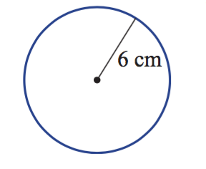**Q1) Find the Perimeter of the following shapes (5 marks)**

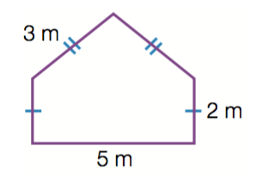**A B**

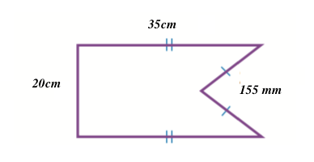

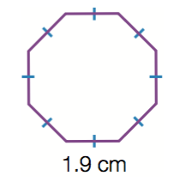

**C D**

**Q2) A security guard walks the perimeter of a rectangular building. If one side of the building is 75m, the other is 150m long. How far would he have walked in an hour if he does 6 laps in an hour?**  **(2 marks)**

**Q3) Find the area of the following shapes**  **(8 marks)**

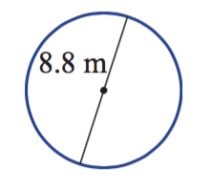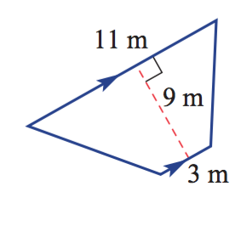 **A B**

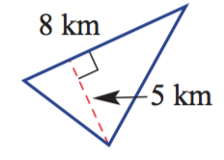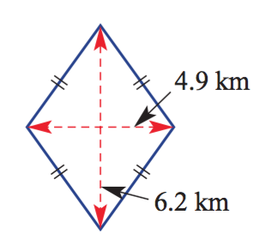

**C D**

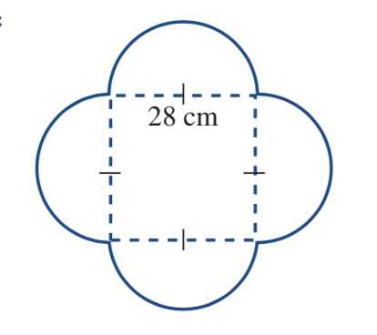**Q4) Find the area of these Composite shapes**  **(12 marks)**

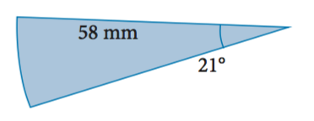 **A B**

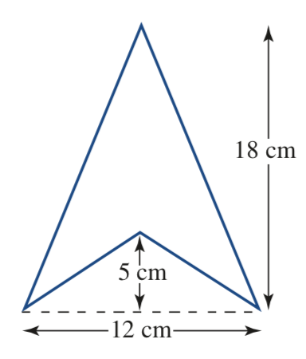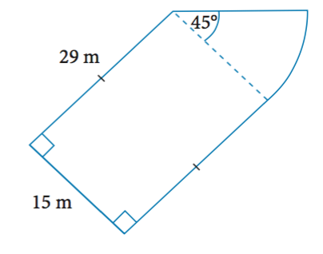

**C D**

**Q5) Find the shaded area of the shape below. (3 marks)**

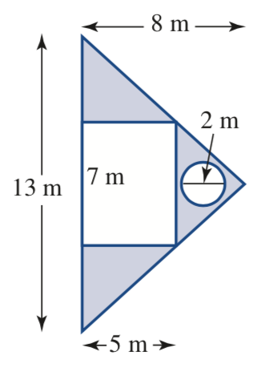

Q6) A farmer wants to section off his trapezium shaped paddock to secure his sheep. The paddock is 400m wide, with the left fence being 1000m long and the right hand fence being 750m long. The back of the paddock enclosure is a diagonal line 472m long, joining the left and right fence. **What is the total area of the field?** **(3 mark)**

1. Draw a Diagram of the scenario.
2. Find the total area of the paddock.

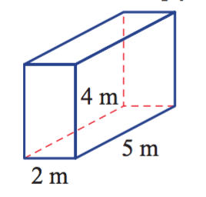**Q7) Find the volume of the following shapes**  **(3+3 = 6 marks)**

**a.**

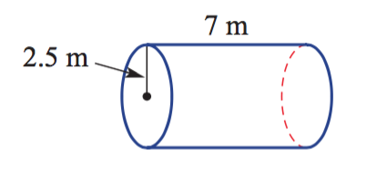**b.**

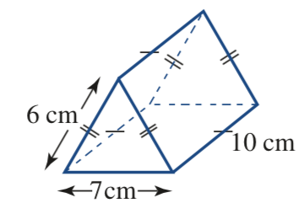**Q8) Find the Total Surface area of these shapes? (4+5 = 9 Marks)**

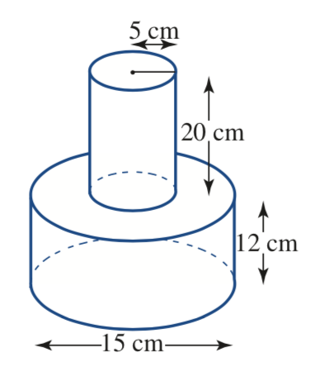**b.**

**Q9) The local aquatics center wants to know the total volume of their pool. (9 Marks)**

1. 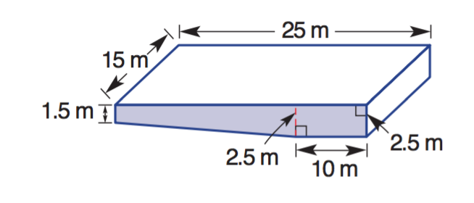**Calculate the volume of the pool below.**

1. **If it costs $150 per KL to of water, how much would it cost to fill the pool?**
2. **They decide to build a new pool. They make the overall length 50m, the deep end base 20m and the width 25m. Re draw the diagram of the pool and find the total capacity of the new pool?**

**END OF ASSESSMENT**